Vector Graphic Purpose, Features and Effect

Description of graphic | 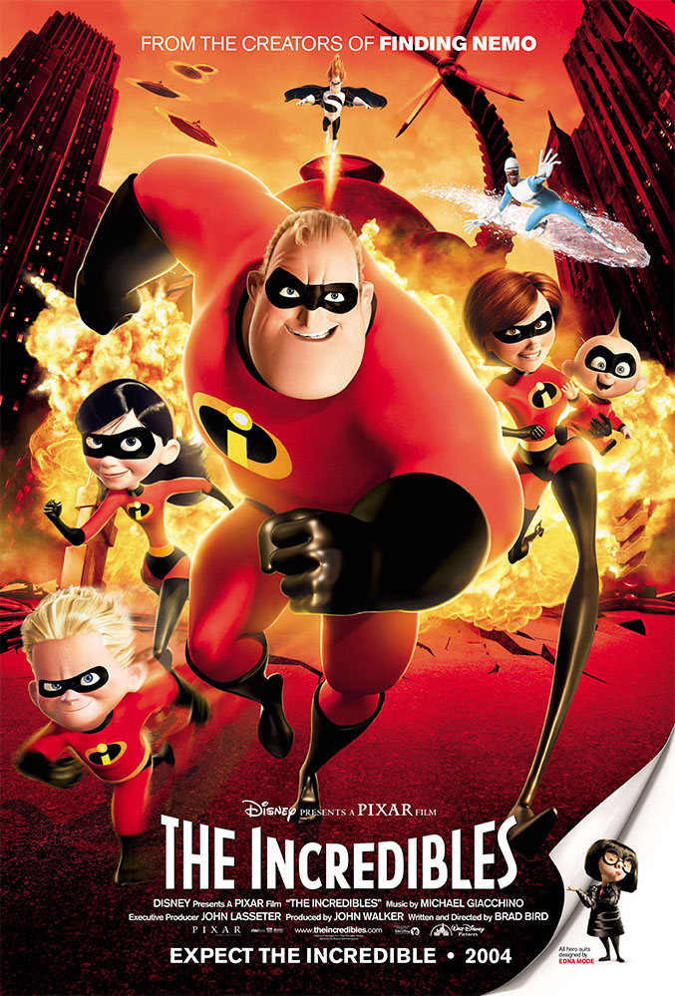The image is a poster of a kid’s film called the incredibles which is a film coming out and this is an ad for the film. Also the text at the bottom of the poster is the names of the people working on the film like the director, the actors, actress and the company that made the film and they put their past films to help to sell this one. Also they included the text because they want to help sell the film to their audience.
Where did you find it? | ohmy.disney.com this is the website to find the image.
What type of graphic is it?  (e.g. logo, sign, diagram, movie or game image, etc.) | The image is a cross between vector graphic and a bitmap graphic and it is a movie poster of the incredibles. Also the reason I picked this image is because you can find character in the image like the style.
What size, resolution, position is the graphic? | The size of the image is 9.1cm height and 6.17cm wide and the size of the image in a file is 272.6 KB and the resolution of the image is very good because the image does not get pixelated and the back of the image looks the same as the front of the image. Also the position of the things in the image is that the main characters are at the front of the image and the villain and the supporting character are at the back. Also the image does not loose resolution if you make it bigger or smaller this is because the image is a cross between a vector images and a bitmap image.
Define the composition of this graphic, stating whether it fulfils the requirement of  Symmetry, Rule of thirds, Patterns / textures and framing. | The colours of the poster are red, yellow and blue and black theses colours help you know how which characters are and what team they are on. The style of the image is cartoony because the way they are animation and the way they are dressed. Also the background colours are the same as the front and the lighting in bright with lots of red. Also there is not a tagline because there is a title and other information. Also the orientation is portrait. Also the image does not have symmetry because if you cut it in half it would not be exact mirror image because different object and colours would be on different sides so it would not be symmetry. Also there is framing because they lay it out so your eyes will go to the front part with the name of the film and they make the character at the front the Biggert’s because he is the main character so your eyes will be forced on that first. Also the image does have the rule of thirds because if I was to make the layout of the rule of thirds on the image the centre part with the name of the film, the main character and the main villain these things would be the point of interest of the image.
What is its purpose?  (e.g. to inform, entertain, identify, etc.) | The purpose of the graphic is to inform because it tells you about that there is a film called the incredibles is coming out so you can get the chance to see it. Also it can entertain because young kids will be entertained because of the colours and art style and some adults may be entertained by it too.
What are the main features of the graphic? | The main features of the poster are that there is a lot of characters on the poster which is showing how many main characters there are. Also there Is a robot in the background most likely being a villain and there is a building in the background and there is a bomb going off behind the characters. Also there’s text at bottom of the page which is the title and text on who made it and when it is coming out. Also I thank the text does super impose over the image because some features are covered up by the words but most of the features are very miner.
Who is the main target audience for the graphic?  (e.g age, gender) | The main target audience is kids aged between 3-9 and the gender would be anyone. Also some other ages may like it too because there is an underlining adult themes and some adult like superheroes.
What sort of effect is it intended to have on the audience?  (e.g. invoke emotion, educate, inform, entertain) | The sort of effect it is to have on it audience is to entertain because the audience is kids so when they see the poster they want to see the film. Also it can inform the kids and the family’s that there is a film call the incredibles coming out which they did not know before.
Is the graphic suitable (fit) for its intended purpose?  (Explain how it meets its purpose.) | The graphic is a suitable fit for its purpose because it has all the things that it needs to entertain like the colours and the people in the poster who would entertain with the clothes they are using and that they have super powers. Also it does inform because it tells you the name, who crated it and their others films they had made and the year in which it coming out.
What are the strengths of this graphic? (at least two) | First strength- the strength is that the poster does not try and mislead the audience because it shows what it will be like the colours and the characters who look like they belong in the poster and do not look out of place.  Second strength- it does not give too much of the movie’s plot away so they some level of mystery because it makes the audience want to find out more about the film and it characters.
What are its weaknesses? (at least two) | First weaknesses- the weakness of the poster is that it only uses one main colour which is red, therefore it doesn’t stand out as much as it would if it had a variety of colours.  Second weaknesses- the second weaknesses of the poster is that they should have a better location in the background because the location that they have in the image is not very interesting.
Any other comments? | They should have not put the blue character which also known as Frozone because the colour does not fit in with the other colour which is red and it looks out of place but I understand why he is in there because he is a main character in the film.

Bitmap Graphic Purpose, Features and Effect

Description of graphic | 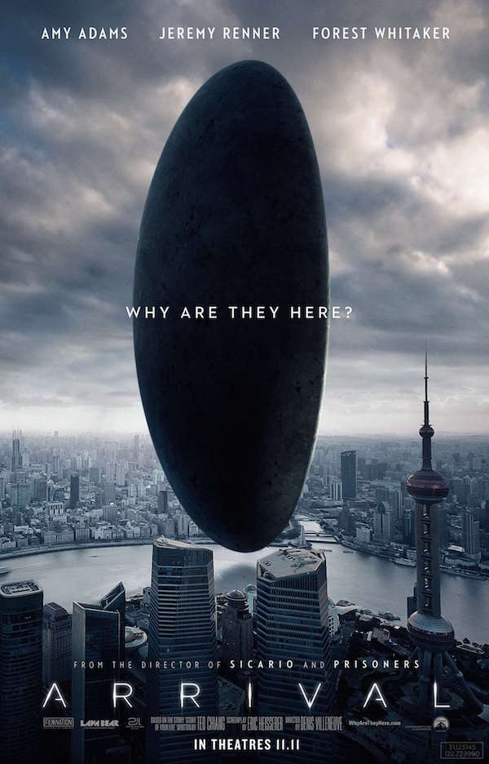 The poster is of a film called the arrival. Also in this image there is a UFO in most of the image within the city of Shanghai. Also there is text on the image telling us about what the film name and the people who made it.
Where did you find it? | designtaxi.com this is where the website is to find the image.
What type of graphic is it?  (e.g. logo, sign, diagram, movie or game image, etc.) | This is a bitmap graphic of a movie poster of the film the Arrival. Also the reason I chose this image is that it has a lot of things happening in the image and it implies things that will happen later in the movie.
What size, resolution, position is the graphic? | The size of the graphic is 8.94cm in height and 5.74cm wide and the file size is 54.7 KB and the resolution is good but you cannot see the background objects very well but the focus of the image is the objects flying on top of the building and the title and the tagline and all of this is very clear. Also the position of the objects in the image are arranged so that the objects which are the main part of the plot are at the front of the poster.
Define the composition of this graphic, stating whether it fulfils the requirement of  Symmetry, Rule of thirds, Patterns / textures and framing. | The composition of the poster is that it would not be symmetry because if you cut it in half it would not be the same on each side. Also I do not thank the poster has the rule of thirds and I think there are patterns on the poster like the object shares a similar colour to the sky and the city and the clouds have patterns to and the framing shows that the most imported object is the one that takes up most of the frame. Also the colours are dark and grey with a little bit of light coming out and this is what gives the poster is intriguing themes. Moreover, the style is real life shots with some computer created parts which would be the object flouting because the object is not real. Also there are textures like the water and the manmade objects.
What is its purpose?  (e.g. to inform, entertain, identify, etc.) | The purpose of the graphic is to inform that there is a film coming out and it’s to entertain/educate because the poster has a science theme this would interesting to the target audiences and the film would be boring too people who are not interested in this type of film and the audience size it will attract would be a small to medium size because kids will not be interested because kids have shot attention span and a small amount of adults would also not be interested.
What are the main features of the graphic? | The main features of the poster are that there is a UFO on the front cover of the poster and it is in a city with lots of buildings and the city I think is Shanghai in China. Also the weather in the poster is dark and lots of clouds and this gives the audience a sense of intrigue and mystery to the poster. Also it shows us the name of the film and tagline and everyone who is in it and the date in which it is in cinemas as well as the names of everyone who was behind the scenes who worked on it. Also one other feature is the tagline which is “why are they here”.
Who is the main target audience for the graphic?  (e.g age, gender) | The main target audience of the image is men and some women aged between 20-70 years old as young people prefer movies that are funny or have loads of action in it. But there might be people who are a higher age or lower age who want to see it this is because this film looks more for people who like science and who like the art of film making.
What sort of effect is it intended to have on the audience?  (e.g. invoke emotion, educate, inform, entertain) | The effect it has on the intended audience is to entertain and educate because if some see the poster they may get entertained by the type of film that it is and that they like the subject which is science. Also they may get educated on the science of space and living things and how they work and how life is formed on other planets.
Is the graphic suitable (fit) for its intended purpose?  (Explain how it meets its purpose.) | The is a suitable fit for the purpose and it meets the purpose because it shows an object that is not of this world on the poster and the tagline tells us that it is going to be about aliens which should entertain the target audience. Also the education comes from them the character talking about the science of the objects they have seen which the audience would like.
What are the strengths of this graphic? (at least two) | First strength- the first pro is that the poster does not mislead the audience and shows them what the movie is about and the themes that are going to be in it.  Second strength- the second pro is that gives off a level of intrigue and this gets the audience wanting to know how the film starts and ends.
What are its weaknesses? (at least two) | First weaknesses- the first weakness is that the poster gives possibly to little information because you do not get to see the characters or now their name so some people may not want to see it because they do not know what they are getting in too.  Second weaknesses- the second weakness is that they should have chosen a different city that people know to be in the background because some people may not get invested because they do not know the city so they may not care.
Any other comments? | I think they should have made the background darker because it would better show the mystery and it would show more of the scary themes that are possibly in the movie and that would better fit the poster and the film it is trying to portray.

